# PulseEKKO GPR Quick Guide

The guide below provides the basic information on how to assemble the GPR system, and collect the GPR data, taken from the [PulseEKKO GPR user manual](https://geophysicalequipmentrental.com/files/2020/01/pulseEKKO-Users-Guide-with-Ultra-Receiver-and-DVL-500.pdf) and a reconnaissance trip on 4th -5th March, 2023 by Stefan Nielsen, Jenny Jenkins and Jeroen van Hunen.

## Assembly

1. Layout of the GPR equipment in the two storage boxes

1. A picture containing grass, person, outdoor

   Description automatically generatedA picture containing grass, person, outdoor, yellow

   Description automatically generatedPlace the transmitter and receiver electronic boxes each onto the black mounting blocks in the middle of an antenna, ensuring the brass sockets connect to the brass pins in the antenna. Connect the electronics boxes to the mounting block using the two plastic draw latch connectors.
2. Place one battery on each side of each of the electronics boxes. Make sure the positive (+) terminal faces inward toward the electronics. NOTE: The battery is “keyed” with a notch in one side, so it only fits properly in this orientation. Close and latch the battery covers – **Don’t try to force anything if it won’t go!**
3. 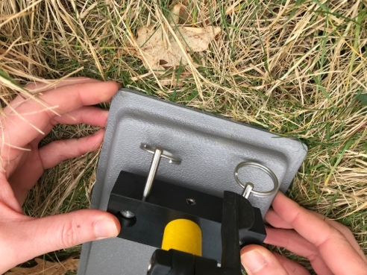To attach the adjustable handle to the antenna, place the handle blocks over the 4 posts on the antenna and insert the pins to secure. Adjust the handle height by loosening the two black levers by hand. Move the handle to the desired height and then retighten the levers. Once the handles are adjusted, lock them by tightening the levers until they click into place.
4. Attach antennas to the skid plates with Velcro ties.

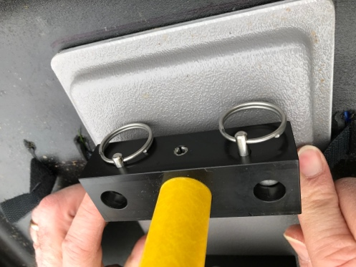

1. Connect the cables: one connection runs a fibre-optic cable from the back of the DVL to the receiver (red circles) and then another from the receiver to the transmitter (green circles). Make sure the colour on the jackets match the colour of the sockets: black to black and grey to grey.

**FIBRE OPTIC CABLES ARE DELICATE & EXPENSIVE – HANDLE WITH CARE**

1. Connect the power cable from DVL viewer (blue circle) to the DVL battery that can be carried in the designated backpack.

## Data Collection

1. First power up the transmitter and receiver (by pressing the On/Off button on the top of the units). The red Power LED on the top of the unit will flash five times and then stay on to indicate the unit is ready for operation. If the unit doesn’t turn on, check that the transmitter and receiver batteries are fully charged and installed correctly.
2. To start the DVL viewer system, press the red power button. The LED on the front panel will light up red. The smaller LED directly above it indicates the battery status: from green (>20%) to orange to red (<10%).
3. The DVL is operated through te touch-screen or the buttons below the screen:

1. Choose System Configuration. This will show the screen below. Choose a survey name (white bar on top). Small antennas are for 200 MHz recordings (large ones are for 50 MHz). The number of stacks is a multiple of two: 32768 doesn’t take too long to record (<1 sec) but gives high signal/noise results. The skid plates on the photo above are set up for a 0.5 m antenna separation and ‘broadside’ polarisation. Set the step size to the distance between subsequent measurements. Press ‘back’ to go back to the main menu.

1. Choose ‘scope mode’: Scope Mode enables you to correctly set the First Break. The red line should be as indicated in the figure to the left. If not, adjusting can be done by the ‘Auto Detect First Break’ option (can crash the system…), although this does not always work well for the high frequencies used in our setup. With the arrows you can adjust it manually (large arrows to start moving, press again to stop moving; small arrows move the red line by a small increment). Once finished, press ‘back’.

Worth noting that you will be able to set the first break of each trace during post-processing as well.

1. Choose ‘run system’ to select the name of the project. Then press ‘back’.

1. Graphical user interface, application

   Description automatically generatedChoose ‘line scan’ to start the actual survey.
   1. Note 1: the system always seems to complain about low battery “battery critically low” message – this is inaccurate – ignore it.
   2. Note 2: DON’T press the ‘no save mode’.
   3. Note 3: try to keep electronics (such as the GPS system) away from the GPR during measurements, as they will interfere.
2. Press ‘start’. Then press the ‘down’ button to make a single measurement (a beep will sound during the measurement: don’t move the device during this beep). Keep repeatedly pressing the down button to make new measurements.

1. A display of results will slowly move in from the right of the screen. Once finished, press ‘stop’ and then ‘back’.

You can adjust the display of results, changing the colour palette, gain or depth extent shown using the viewing options at the bottom of the screen

